DAY-2 (15/5/2025)

Emp ID : 110714877

NAME :Kinnera venkatamma

Git Commands ::

Git init , git add .(all) , git status

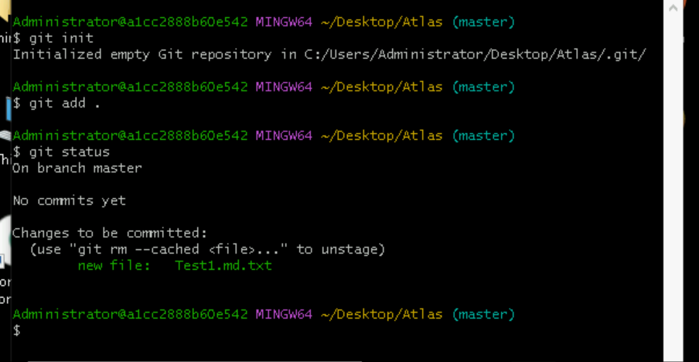  
git commit

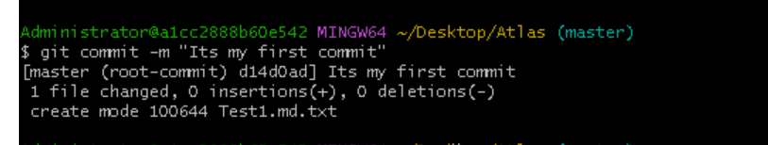

git config

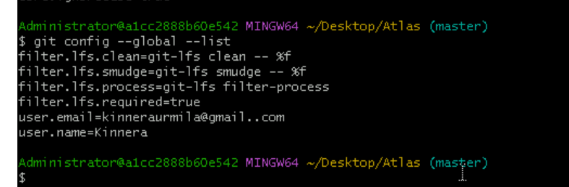

git remote add origin, git branch -M main ,git push -u origin main

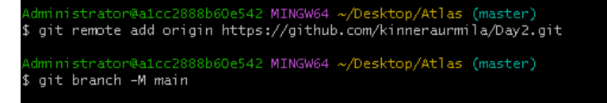

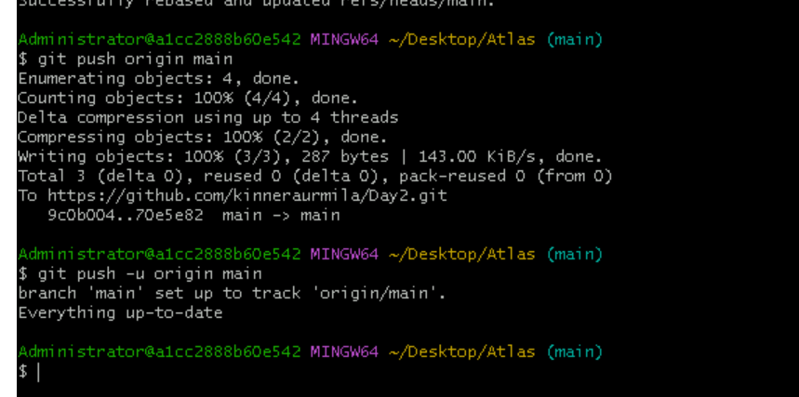

git log

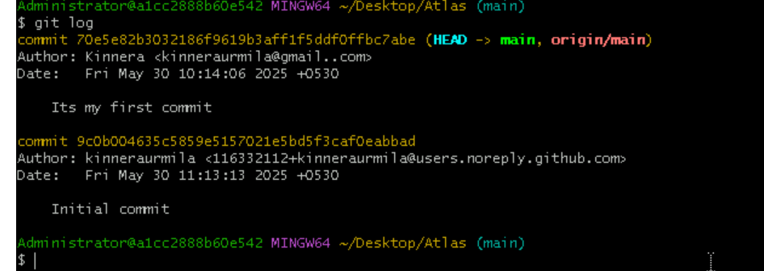

git show

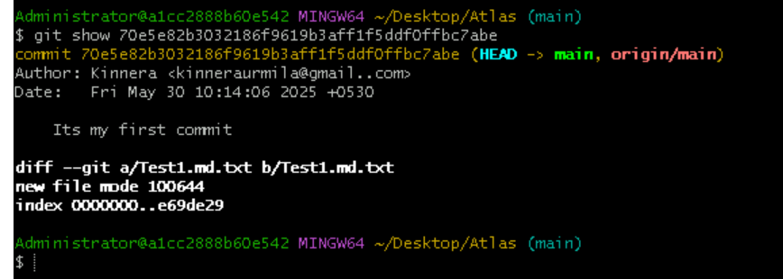

.gitignore file

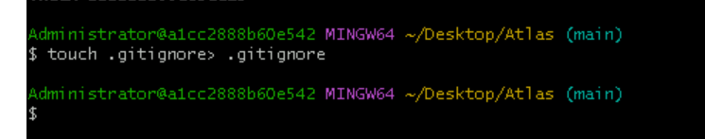

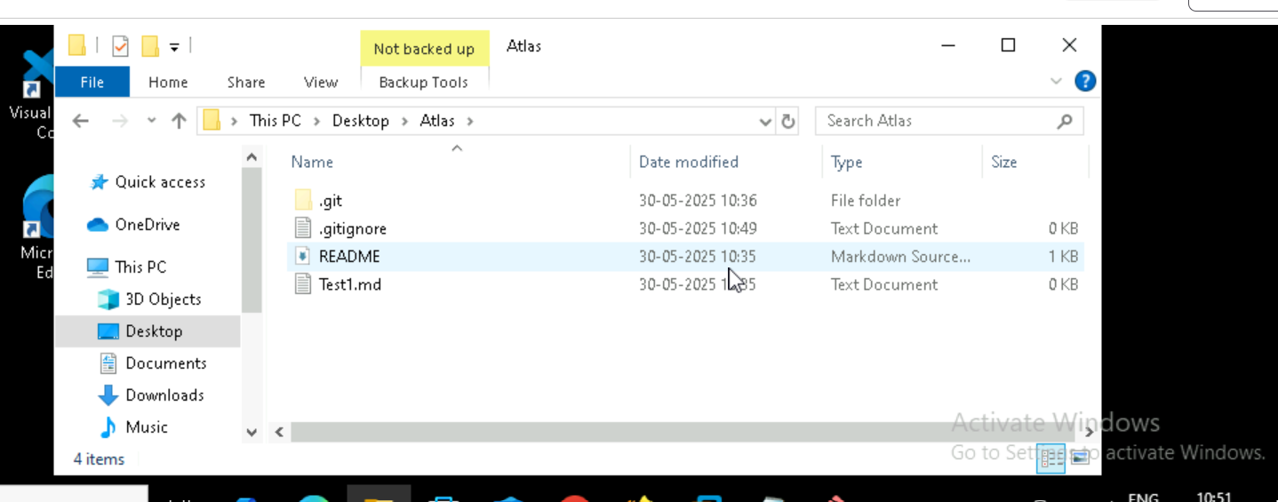

git clone ,git push & pull

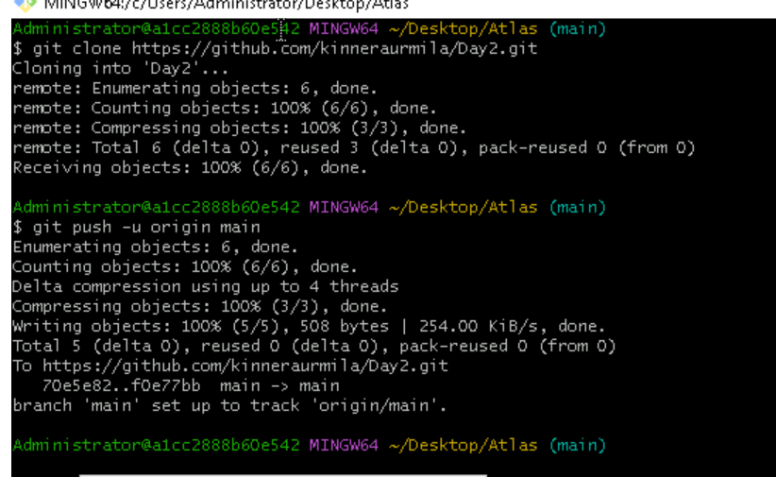

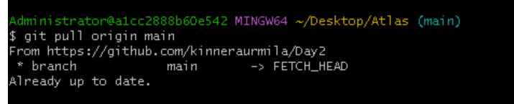

git branch ,creating new branch ,changing branch

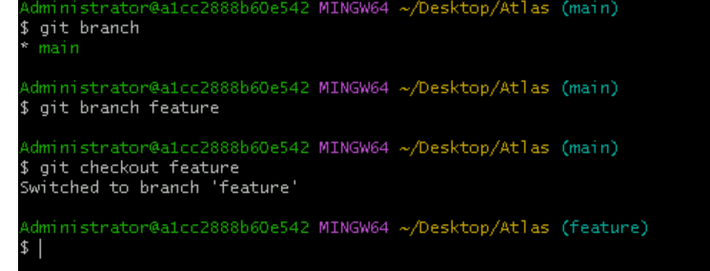

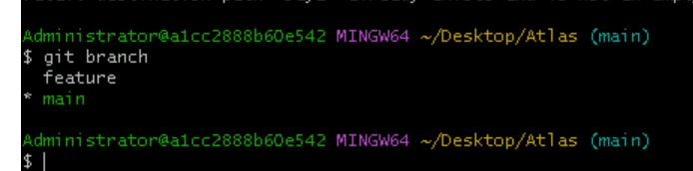

git merge

